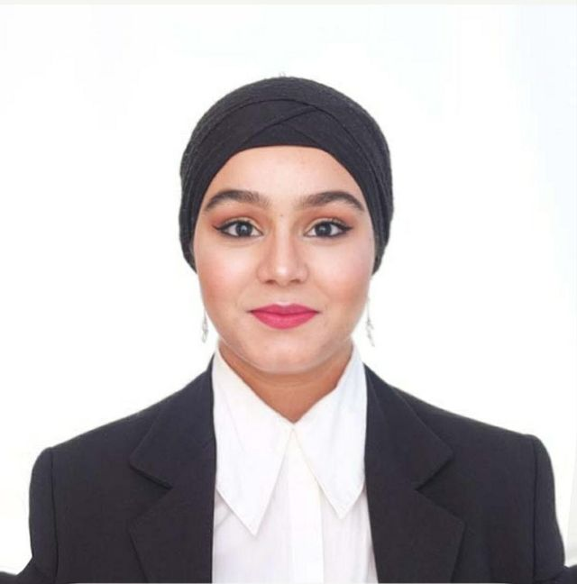 Instagram: Rahil Mokhtari

Whatsapp : 0508060474 ( need QR code)

Wechat: Rahil ( need QR code)

**Rahil Mokhtari - English Teacher**

**Date of Birth**: January 7, 1998

**Educational Background:**

* Bachelor's Degree in English Teaching
* Master's Degree in Translation (English, French, Arabic

Hello, my name is Rahil Mokhtari, and I am the English teacher at Hand by Hand Institute. I hold a Bachelor's Degree in English Teaching and a Master's Degree in Translation, specializing in English, French, and Arabic. I am proficient in all three languages.

I have had the privilege of teaching at numerous educational institutions, including private schools, where I have worked with students across various age groups and proficiency levels. My teaching experience encompasses phonics for children, comprehensive language skills for teenagers, and speaking, writing, and reading for adults.

For the past year and a half, I have been a dedicated educator at the Hand by Hand Institute. I have treasured every moment spent here with my exceptional students and deeply value the opportunity to contribute to their academic growth and development.

My teaching philosophy is centered on creating an engaging and supportive learning environment that empowers students to reach their full potential in language proficiency.

I am enthusiastic about continuing this journey and making a meaningful impact on my students' lives.